**VPX Preventative Maintenance**

***Cleaning the inlet filter:***

Unscrew filter counter-clockwise. Use a small tool to remove the screen. Use acetone, alcohol, or any like cleaning agent along with a towel and/or Q-tip to clear the screen of any debris. Blow the screen off using canned air. Insert the screen back into filter along with the o-ring (THE ORING SHOULD BE FACING YOU). Blow through filter again. Screw the filter clockwise into the inlet filter housing. NOTE: Again make sure the o-ring was facing you when you put it together. That is how it seals to the housing.

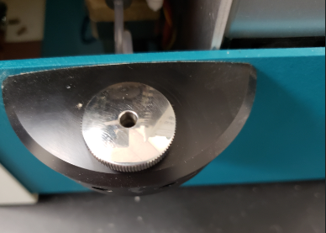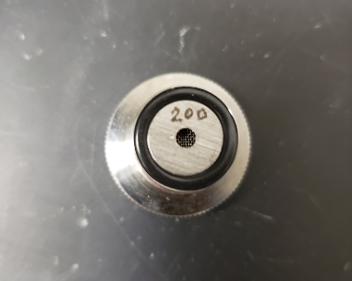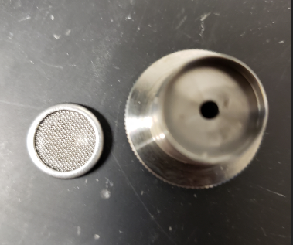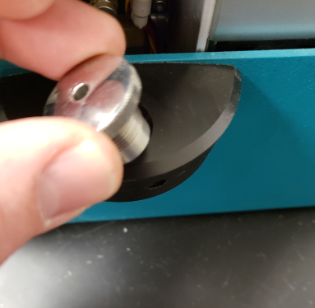

**Daily cleaning:**

At the end of the day I recommend cleaning the unit of any oil, gasoline, paraffins, etc. This will ensure you will not clog up the filter and the tubes throughout the unit. To do this simply connect your cleaning agent of choice (Acetone, Varsol, Toluene or any like cleaning agent) to the inlet of the unit and hit the Rinse function on the main screen (should be set to 3 rinses). After it is done rinsing then disconnect your cleaning agent and rinse again 3 times with nothing connected (this is called a dry run). Your unit is now ready for the next use.

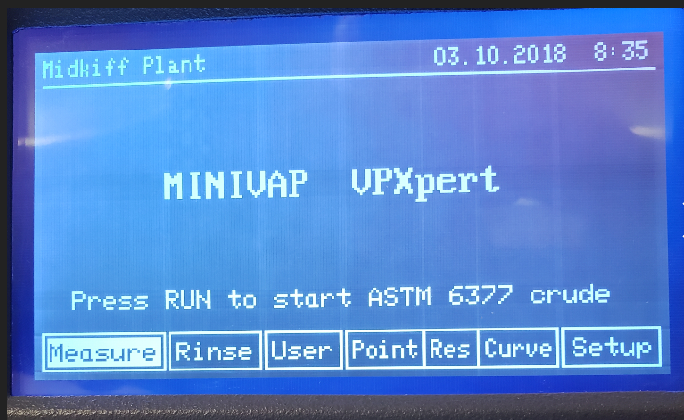

**Other:**

Keeping a Dust cover or something similar over the unit while not in use (power off) helps keep dust out of the unit and from harming any of the electronics.